**Name: Dhananjay Narayan Kuber**

**Roll No.: 35036**

**Subject: Web Application Development**

**Lab Assignment No. 2 A**

**Title: Create version control account on GitHub and using Git commandsto create repository and push your code to GitHub.**

1. Download and install git bash
2. Configure Github user

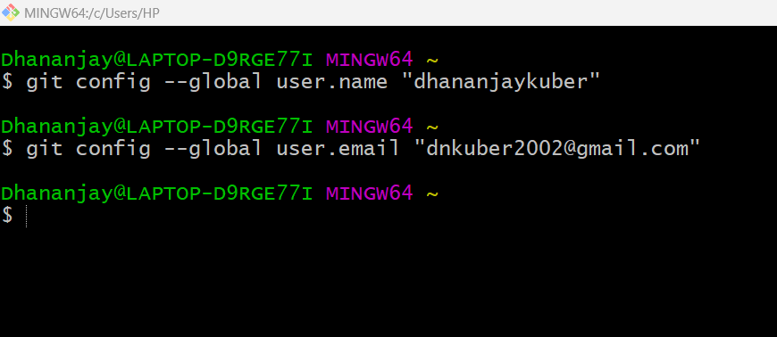

1. Initialize project



1. Add all files to the staging area

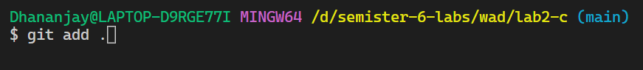

1. Commit the changes with a message

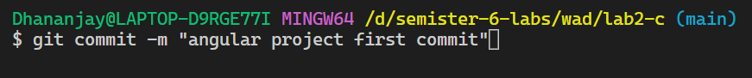

1. Switch to the main branch

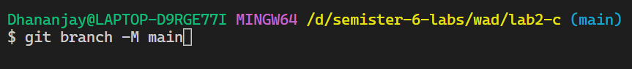

1. Add remote origin for local git project

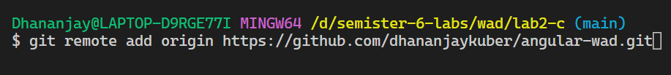

1. Push the local code to GitHub on the main branch

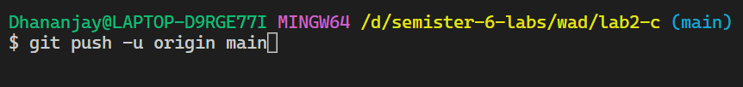

1. Check the logs

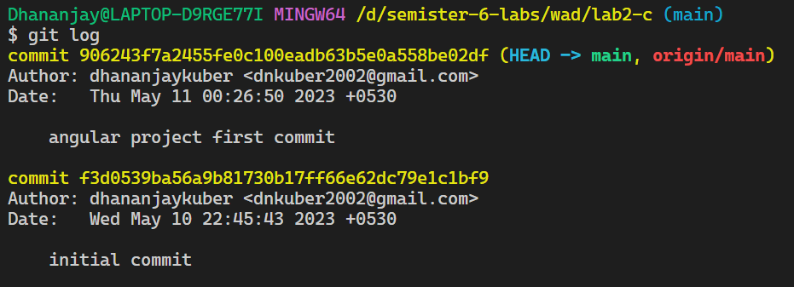

1. Check git status

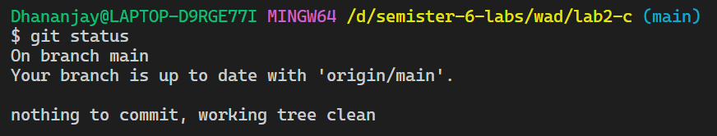

1. Switch to other branches

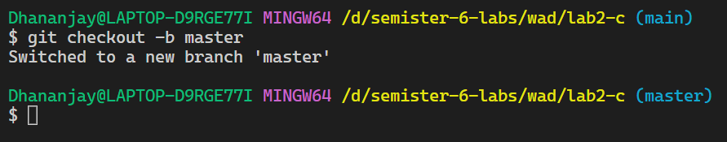

1. The project pushed on GitHub

